ASSIGNMENT 11.1

1)A Hive program to find the number of medals own by each country in swimming.

1.Step 1 is to create the table by the name Olympic .The row format is delimited.

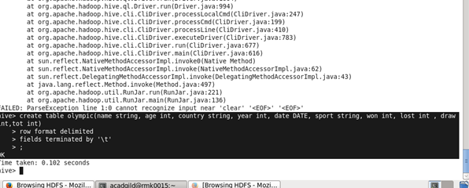

2.Here we are displaying the country and number of medals own by the country by using the select command.

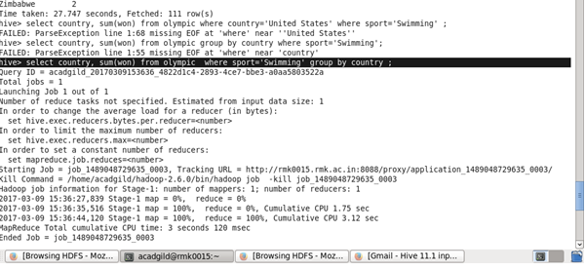

OUTPUT:

The output contains the country name along with the number of medals own by each country.

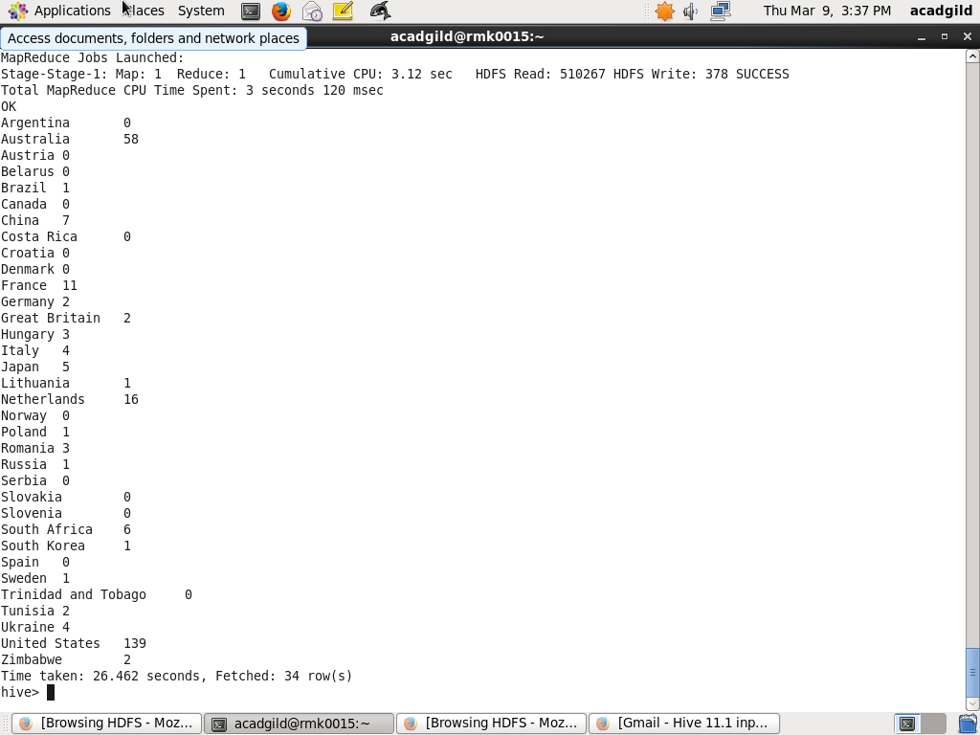

2)Hive program to find the number of medals that India won year wise.

A)

1.The select command is used to display the year and the medals own by India the yearwise.

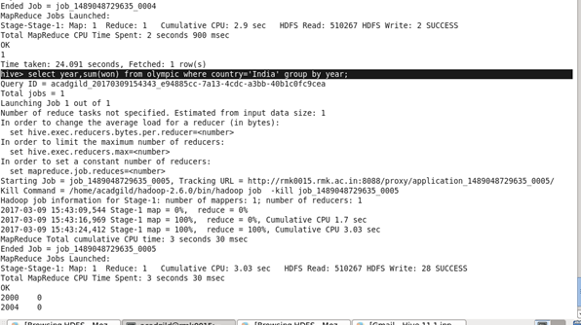

Output:

The output contains the year and the number of medals own by India in each year.